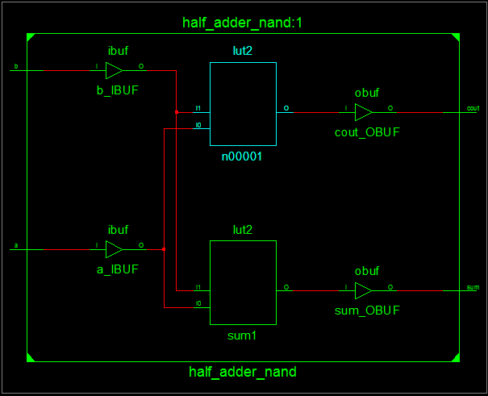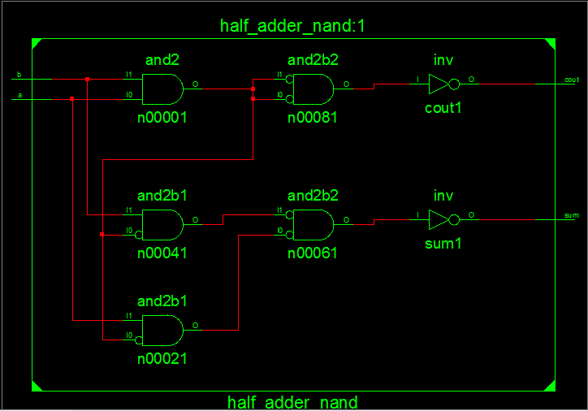Half adder using nand gates RTL Schematic

Half Adder using nand gates Technology Schematic

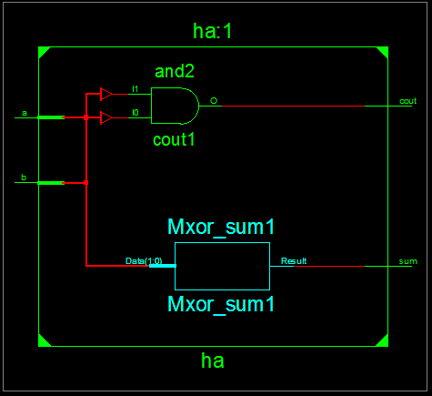

Adder using Continuous Assignment RTL Schematic

Adder using Continuous Assignment 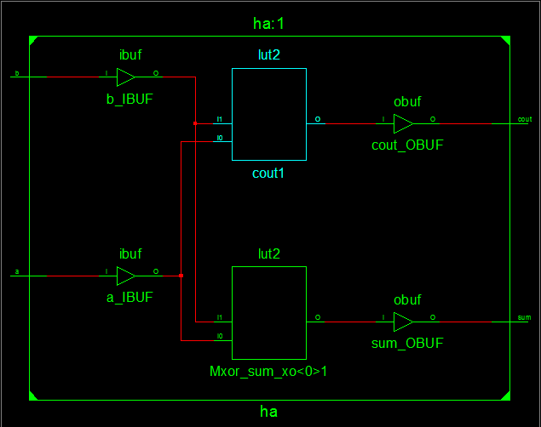Technology Schematic